November Notices 2021
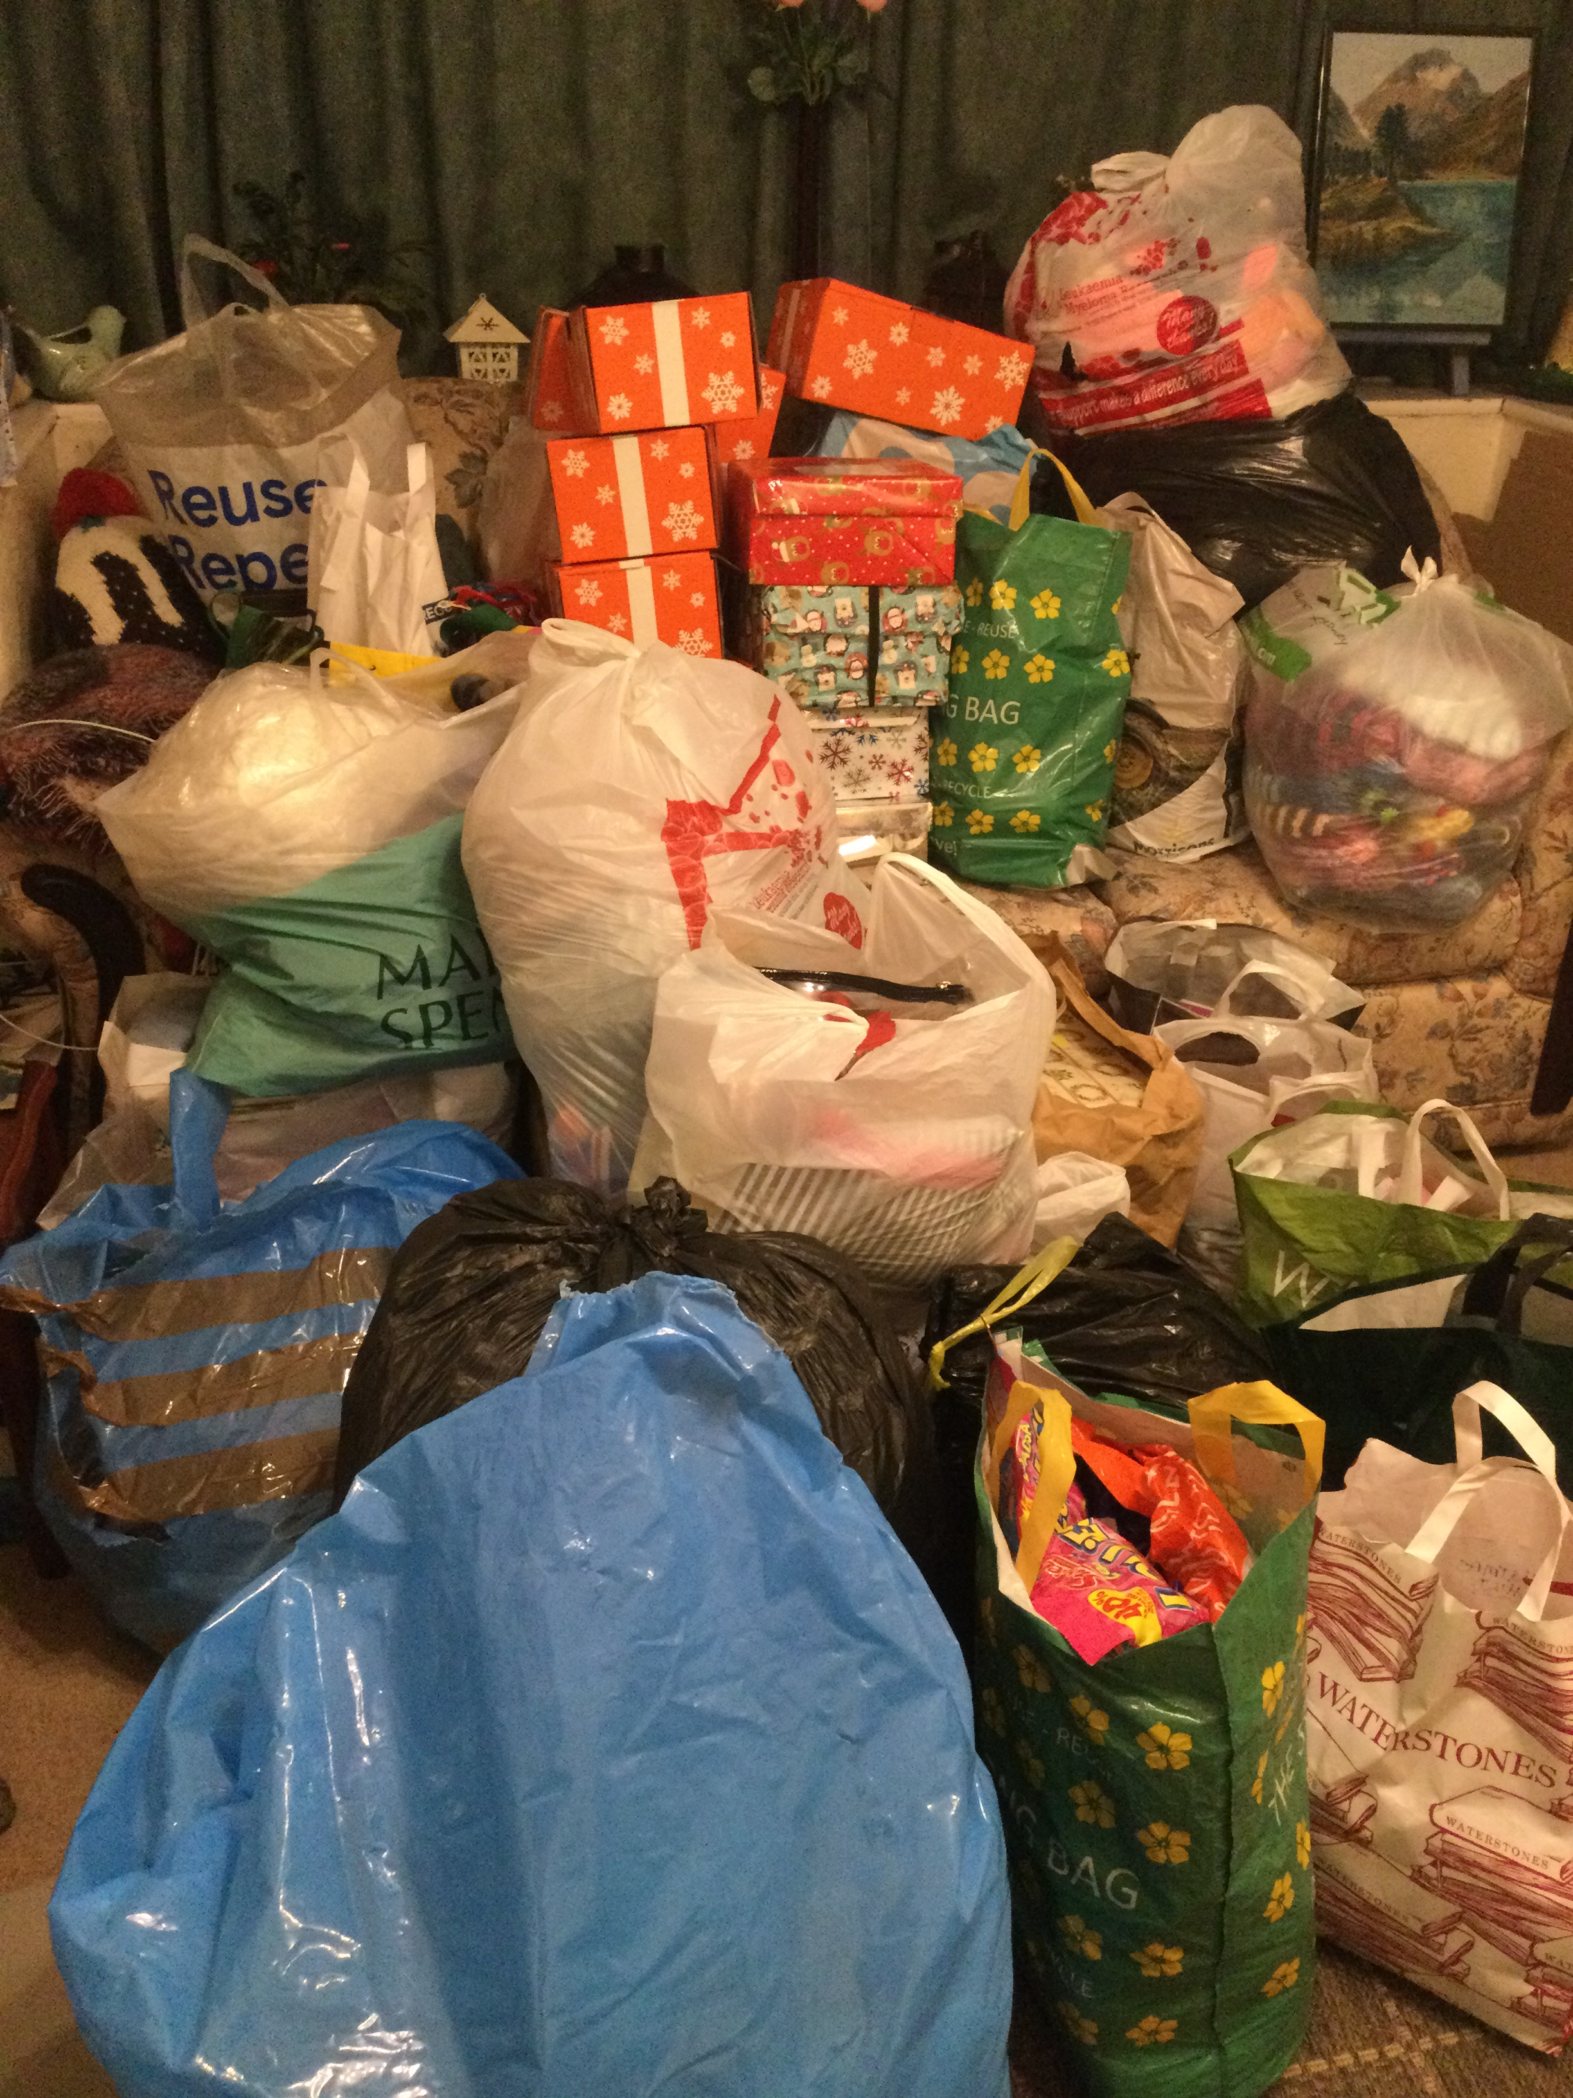
Christmas Shoe Boxes: This year, we have collected 156 boxes, at least
10 very large bags of gifts and £124.70 donations. A huge WELL DONE
and thank you to everyone who’s contributed in any way. Amazing! And
many thanks also to Carole and Liz for all their hard work.

Living in love and Faith survey: There’s a short survey for each person
to complete – (attached it for those who receive this by email and paper copies at Church.) The Church of England is asking “what is God saying to the Church?” and it’s important each person should have their say. Return it to Church for us to send off or follow the instructions to email or post it on yourself. Many thanks

November Sunday Club: 14th and 28th November 10.30am

Lights of Remembering: Sunday 7th November from 4pm outside Church. 4.30pm Service in Church, followed by refreshments in the hall.

Remembrance Day Sunday 14th November – 10.30am in Church, with a service led by the Werneth Low Trust up at the Cenotaph, on the Low at 12 noon.

New Wine Women’s Day: Still time to book for: Saturday 20th November 10-4pm at St Philip’s Salford. See link below to book or contact Wendy Slinger to be part of the group booking. https://resetmanchester2021.eventbrite.co.uk/?ref=estw

Advent course: Each Monday at 7.30pm for 4 weeks from 22nd November, in the Hall - based on the film: “The Lion, the Witch and the Wardrobe” by CS Lewis. Come and watch the whole film together on Monday 15th November 7.30pm, to get “a feel” for it.
Heads-up for Christmas at Holy Trinity:
Sat 27th Nov. 2 - 4pm Help decorate the tree crafts + refreshments in the hall

5th Dec Christingle 10am and 11.15am BOOKING ESSENTIAL
12th Dec Family Nativity (with donkey) 10am BOOKING ESSENTIAL
11.15am Holy Communion
19th Dec Carol Service 10.30am with speaker from Cascade Baby Bundles
24th Dec Carols by Candlelight 4pm + 6pm BOOKING ESSENTIAL
8pm Christmas Communion
25th Dec Family Celebration + Communion 10am
26th Dec. Short service of Holy Communion 10.30am

We are collecting for:
Cascade Baby Bundles: Moses baskets, sterilisers, other baby equipment and clothes for
babies and children up to 6 years old. (Much needed for Afghan refugees and others).
Two Brews: A homeless charity in Salford would welcome warm clothes - coats, hats, scarves,
gloves, hoodies, socks and sleeping bags.
Please bring any donations to Church or leave in the porch at 8, Kensington Street, SK14 5QD

Foodbank: Help is requested at the Tesco Extra Hattersley on 18th – 20th November to ask shoppers to “Buy and extra tin for the Foodbank” Ask Helen for more details.

November Notices 2021 (Part 2)

You are invited to:
Come, Help Decorate the Tree Sat. 27th November 2-4pm in the church hall. Christmas Tree Crafts + Refreshments (table service) then put them on our Christmas tree in church.

Christmas Cards: Our Church Christmas cards (with service details) are very much appreciated round the Parish. If you're able to help deliver a Round, they'll be available in Church on Sunday 28th November. We can't do it without you!

We're delighted that Thursday Club (for the rich in years) has started up again in the hall, at the new time of 12.30-2.30pm (on Thursdays!). If you haven't been before, you're very welcome to come along. Contact Helen (0161 366 7243) for more details.

November Notices 2021 (Part 2)

You are invited to:
Come, Help Decorate the Tree Sat. 27th November 2-4pm in the church hall. Christmas Tree Crafts + Refreshments (table service) then put them on our Christmas tree in church.

Christmas Cards: Our Church Christmas cards (with service details) are very much appreciated round the Parish. If you're able to help deliver a Round, they'll be available in Church on Sunday 28th November. We can't do it without you!

We're delighted that Thursday Club (for the rich in years) has started up again in the hall, at the new time of 12.30-2.30pm (on Thursdays!). If you haven't been before, you're very welcome to come along. Contact Helen (0161 366 7243) for more details.

November Notices 2021 (Part 2)

You are invited to:
Come, Help Decorate the Tree Sat. 27th November 2-4pm in the church hall. Christmas Tree Crafts + Refreshments (table service) then put them on our Christmas tree in church.

Christmas Cards: Our Church Christmas cards (with service details) are very much appreciated round the Parish. If you're able to help deliver a Round, they'll be available in Church on Sunday 28th November. We can't do it without you!

We're delighted that Thursday Club (for the rich in years) has started up again in the hall, at the new time of 12.30-2.30pm (on Thursdays!). If you haven't been before, you're very welcome to come along. Contact Helen (0161 366 7243) for more details.

